ABSTRACT

DIABETES PREDICTION:

Diabetes is a chronic disease with the potential to cause a worldwide health care crisis. According to International Diabetes Federation 382 million people are living with diabetes across the whole world. By 2035, this will be doubled as 592 million. Diabetes mellitus or imply diabetes is a disease caused due to the increase level of blood glucose. Various traditional methods, based on physical and chemical tests, are available for diagnosing diabetes. However, early prediction of diabetes is quite challenging task for medical practitioners due to complex interdependence on various factors as diabetes affects human organs such as kidney, eye, heart, nerves, foot etc. Data science methods have the potential to benefit other scientific fields by shedding new light on common questions. One such task is to help make predictions on medical data. Machine learning is an emerging scientific field in data science dealing with the ways in which machines learn from experience. The aim of this project is to develop a system which can perform early prediction of diabetes for a patient with a higher accuracy by combining the results of different machine learning techniques. This project aims to predict diabetes via three different supervised machine learning methods including: SVM, Logistic regression, KNN. This project also aims to propose an effective technique for earlier detection of the diabetes disease using Machine learning algorithms and end to end deployment using flask.

INTRODUCTION

All around there are numerous ceaseless infections that are boundless in evolved and developing nations. One of such sickness is diabetes. Diabetes is a metabolic issue that causes blood sugar by creating a significant measure of insulin in the human body or by producing a little measure of insulin. Diabetes is perhaps the deadliest sickness on the planet. It is not just a malady yet, also a maker of different sorts of sicknesses like a coronary failure, visual deficiency, kidney ailments and nerve harm, and so on.
Subsequently, the identification of such chronic metabolic ailment at a beginning period could help specialists around the globe in forestalling loss of human life. Presently, with the ascent of machine learning, AI, and neural systems, and their application in various domains [1, 2] we may have the option to find an answer for this issue. ML strategies and neural systems help scientists to find new realities from existing well-being-related informational indexes, which may help in ailment supervision and detection. The current work is completed utilizing the Pima Indians Diabetes Database. The point of this frame work is to make an ML model, which can anticipate with precision the likelihood or the odds of a patient being diabetic. The ordinary distinguishing process for the location of diabetes is that the patient needs to visit a symptomatic focus. One of the key issues of bio-informatics examination is to achieve precise outcomes from the information. Human mistakes or various laboratory tests can entangle the procedure of identification of the disease. This model can foresee whether the patient has diabetes or not, aiding specialists to ensure that the patient in need of clinical consideration can get it on schedule and also help anticipate the loss of human lives.
DNA makes neural networks the apparent choice. Neural networks use neurons to transmit data across various layers, with each node working on a different weighted parameter to help predict diabetes.
Presently, with the ascent of machine learning, AI, and neural systems, and their application in various domains [1, 2] we may have the option to find an answer for this issue.ML strategies and neural systems help scientists to find new realities from existing well-being-related informational indexes, which may help in ailment supervision and detection. The current work is completed utilizing the Pima Indians Diabetes Database.
CAUSES OF DIABETES:

Genetic factors are the main cause of diabetes. It is caused by at least two mutant genes in the chromosome 6, the chromosome that affects the response of the body to various antigens. Viral infection may also influence the occurrence of type 1 and type 2 diabetes. Studies have shown that infection with viruses such as rubella, Coxsackievirus, mumps, hepatitis B virus, and cytomegalovirus increase the risk of developing diabetes.

TYPES OF DIABETES
TYPE 1: -

Type 1 diabetes means that the immune system is compromised and the cells fail to produce insulin in sufficient amounts. There are no eloquent studies that prove the causes of type 1 diabetes and there are currently no known methods of prevention.
TYPE 2: -
Type 2 diabetes means that the cells produce a low quantity of insulin or the body can’t use the insulin correctly. This is the most common type of diabetes, thus affecting 90%of persons diagnosed with diabetes. It is caused by both genetic factors and the manner of living.

Data mining and machine learning have been developing, reliable, and supporting tools in the medical domain in recent years. The data mining method is used to pre-process and select the relevant features from the healthcare data, and the machine learning method helps automate diabetes prediction [14]. Data mining and machine learning algorithms can help identify the hidden pattern of data using the cutting-edge method; hence, a reliable accuracy decision is possible. Data Mining is a process where several techniques are involved, including machine learning, statistics, and database system to discover a pattern from the massive amount of dataset [15]. According to Nvidia: Machine learning uses various algorithms to learn from the parsed data and make predictions.
RELATED WORKS:

Diabetes prediction is a classification technique with two mutually exclusive possible outcomes, either the person is diabetic or not diabetic. After extensive research, we came to conclusion that although numerous classification techniques can be used for the purpose of prediction, the observed accuracy varied. On careful examination of the performance of techniques used in prevalent works, logistic regression, KNN, Naive Bayes [3], random forest, decision tree, and neural network [4], we found the mat par when applied to our dataset. KNN and logistic regression techniques were able to achieve 80% accuracy. The primary factor which influenced our algorithm selection was its adaptability and compatibility with future applications. The inevitable shift of data storage toward DNA makes neural networks the apparent choice. Neural networks use neurons to transmit data across various layers, with each node working on a different weighted parameter to help predict diabetes. The point of this framework is to make an ML model, which can anticipate with precision the likelihood or the odds of a patient being diabetic. The ordinary distinguishing process for the location of diabetes is that the patient needs to visit asymptomatic focus. One of the key issues of bio-informatics examination is to achieve precise outcomes from the information. Human mistakes or various laboratory tests can entangle the procedure of identification of the disease. This model can foresee whether the patient has diabetes or not, aiding specialists to ensure that the patient in need of clinical consideration can get it on schedule and also help anticipate the loss of human lives.

DATA SET: -

The dataset collected is originally from the Pima Indians Diabetes Database is available on Kaggle. It consists of several medical analyst variables and one target variable. The objective of the dataset is to predict whether the patient has diabetes or not. The dataset consists of several independent variables and one dependent variable, i.e., the outcome. Independent variables include the number of pregnancies the patient has had their BMI, insulin level, age, and so on as Shown in Following Table 1:
Table 1 Dataset Description
Serial No. | Attribute Names | Description
1. | Pregnancies | Number of times pregnant
2. | Glucose | Plasma glucose concentration
3. | Blood Pressure | Diastolic blood pressure
4. | Skin Thickness | Triceps skin fold thickness (mm)
5. | Insulin | 2-h serum insulin
6. | BMI | Body mass index
7. | Diabetes Pedigree Function | Diabetes pedigree function
8. | Outcome | Class variables (0 or 1)
9. | Age | Age of patient
Fig 3.1 dataset description
- This diabetes dataset consists of 768 data points, with 9 features each.
- “Outcome” is the feature we are going to predict, 0 means No diabetes, 1 means diabetes.
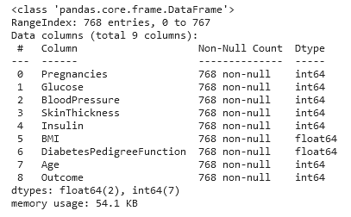
Fig 3.2 Predictions
- There is no null values in dataset.
CORRELATION MATRIX:

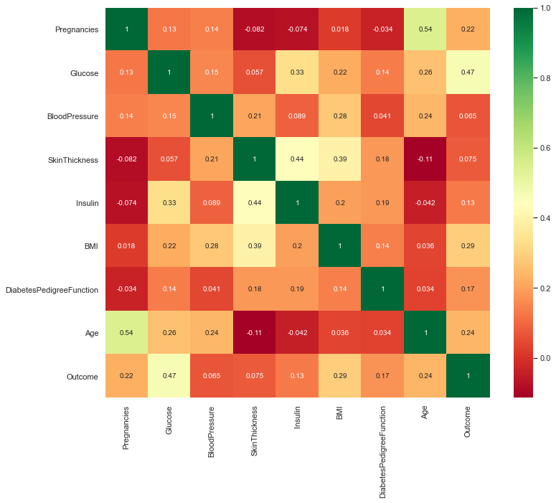
Fig 3.3 Correlation Matrix
It is easy to see that there is no single feature that has a very high correlation with our outcome value. Some of the features have a negative correlation with the outcome value and some have positive.

SKEW OF DATA:

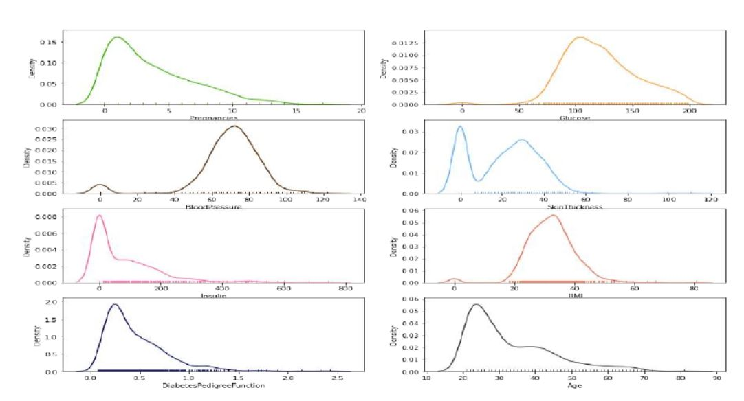
Fig 3.4 Skew of Data
It shows how each feature and label is distributed along different ranges, which further confirms the need for scaling. It basically means that each of these is actually a categorical variable. We will need to handle these categorical variables before applying Machine Learning. Our outcome labels have two classes, 0 for no disease and 1 for disease.

BAR PLOT FOR OUTCOME CLASS
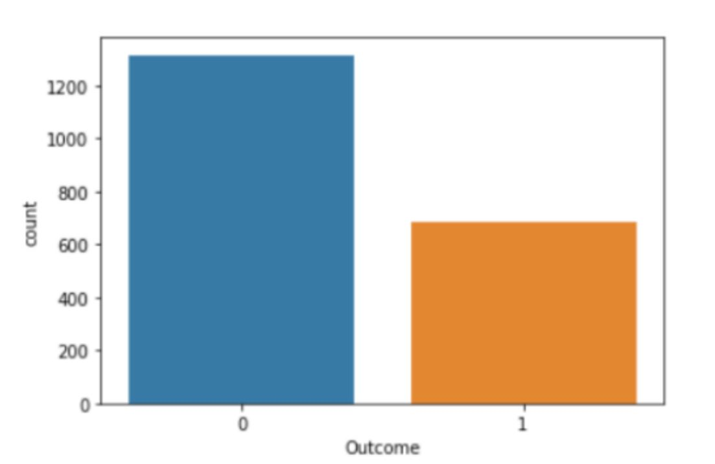
Fig. 3.5 Bar Plot for outcomes class
The above graph shows that the data is biased towards datapoints having outcome value as 0 where it means that diabetes was not present actually. The number of non-diabetics is almost twice the number of diabetic patients.

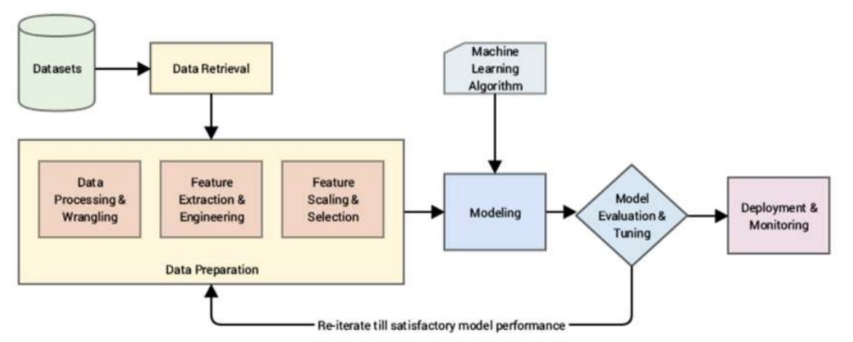
Fig 3.6 Graph
PROPOSED METHODS

I] Dataset collection –
It includes data collection and understanding the data to study thehidden patterns and trends which helps to predict and evaluating the results. Dataset carries1405 rows i.e., total number of data and 10 columns i.e., total number of features. Features include Pregnancies, Glucose, Blood Pressure, Skin Thickness, Insulin, BMI, Diabetes Pedigree Function, Age

II] Data Pre-processing:
This phase of model handles inconsistent data in order to get more accurate and precise results like in this dataset Id is inconsistent so we dropped the feature. This dataset doesn’t contain missing values. So, we imputed missing values for few selected attributes like Glucose level, Blood Pressure, Skin Thickness, BMI and Age because these attributes cannot have values zero. Then data was scaled using Standard Scaler. Since there were a smaller number of features and important for prediction so no feature selection was done.

III]Missing value identification:
Using the Panda library and SK-learn, we got the missing values in the datasets, shown in Table 2. We replaced the missing value with the corresponding mean value.
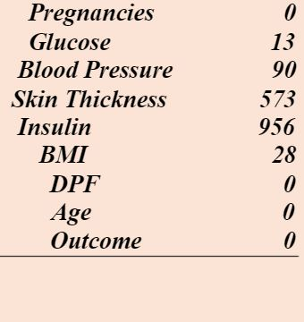
Fig 4.1 Missing value identified

IV] Feature selection:
Person’s correlation method is a popular method to find the most relevant attributes/features. The correlation coefficient is calculated in this method, which correlates with the output and input attributes. The coefficient value remains in the range by between −1 and 1. The value above 0.5 and below −0.5 indicates a notable correlation, and the zero value means no correlation.
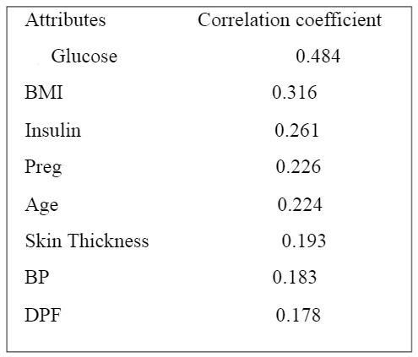
Fig 4.2 Correlation Table:
V] Scaling and Normalization:
We performed feature scaling by normalizing the data from 0 to 1 range, which boosted the algorithm’s calculation speed. Scaling means that you're transforming your data so that it fits within a specific scale, like 0-100 or 0-1. You want to scale data when you're using methods based on measures of how far apart data points are, like support vector machines (SVM) or k-nearest neighbours (KNN). With these algorithms, a change of "1" in any numeric feature is given the same importance.
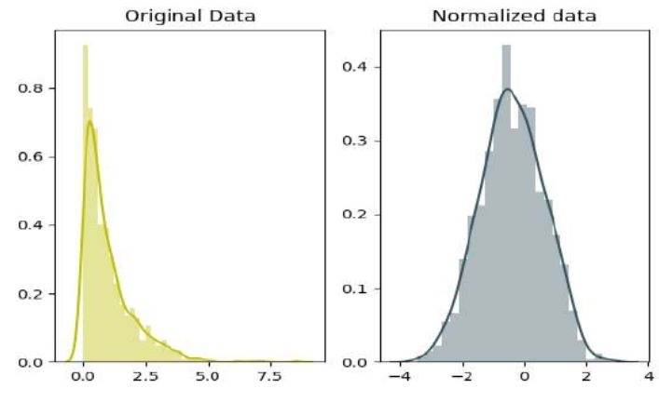
Fig 4.3 Scaling and normalization
VI] Splitting of data:
After data cleaning and pre-processing, the dataset becomes ready to train and test. In the train/split method, we split the dataset randomly into the training and testing set. For Training we took 1600 sample and for testing we took 400 sample.

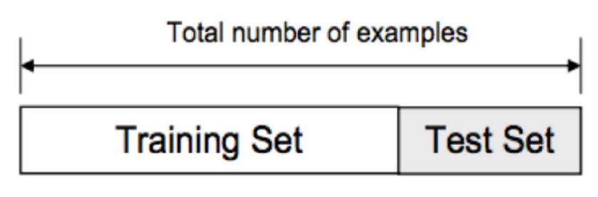
Fig 4.4 Spitting Data

VII] Design and implementation of classification model:
In this research work, comprehensive studies are done by applying different ML classification techniques like DT, KNN, RF, NB, LR, SVM.
VIII] Machine learning classifier:
We have developed a model using Machine learning Technique. Used different classifier and ensemble techniques to predict diabetes dataset. We have applied SVM, LR, DT and RF Machine learning classifier to analyse the performance by finding accuracy of each classifier. All the classifiers are implemented using scikit learn libraries in python. The implemented classification algorithms are described in next section.

MODELING AND ANALYSIS:

A] Logistic Regression:
Logistic regression is a machine learning technique used when dependent variables are able to categorize. The outputs obtained by using the logistic regression is based on the available features. Here sigmoidal function is used to categorize the output.
B] K-Nearest Neighbors:
K-nearest neighbors (KNN) algorithm uses ‘feature similarity’ to predict the values of new datapoints which further means that the new data point will be assigned a value based on how closely it matches the points in the training set. Predictions are made for a new instance (x) by searching through the entire training set for the K most similar instances (the neighbors) and summarizing the output variable for those K instances.
C]SVM:
SVM is supervised learning algorithm used for classification. In SVM we have to identify the right hyper plane to classify the data correctly. In this we have to set correct parameters values. To find the right hyper plane we have to find right margin for this we have choose the gamma value as 0.0001 and rbf kernel. If we select the hyper plane with low margin leads to miss classification.
D] Naive Bayes:
Naive Bayes classifiers are a collection of classification algorithms based on Bayes’ Theorem. It is not a single algorithm but a family of algorithms where all of them share a common principle, i.e. every pair of features being classified is independent of each other.
E] Decision Tree:
Decision tree is non parametric classifier in supervised learning. In this method all the details are represented in the form of tree, where leaves are corresponds to the class labels and attributes are corresponds to internal node of the tree. We have used Gini Index for splitting the nodes.

F] Random Forest:
Random forest is an ensemble learning method for classification. This algorithm consists of trees and the number of tree structures present in the data is used to predict the accuracy. Where leaves are corresponds to the class labels and attributes are corresponds to internal node of the tree. Here number of trees in forest used is 100 in number and Gini index is used for splitting the nodes.
G] AdaBoost Classifier:
Boosting is an ensemble modelling technique that attempts to build a strong classifier from the number of weak classifiers. It is done by building a model by using weak models in series. Firstly, a model is built from the training data. Then the second model is built which tries to correct the errors present in the first model. This procedure is continued and models are added until either the complete training data set is predicted correctly or the maximum number of models are added.
AdaBoost was the first really successful boosting algorithm developed for the purpose of binary classification. AdaBoost is short for Adaptive Boosting and is a very popular boosting technique that combines multiple “weak classifiers” into a single “strong classifier”. It was formulated by Yoav Freund and Robert Schapire. They also won the 2003 Gödel Prize for their work.

MEASUREMENTS

To find the efficient classifier for diabetes prediction we have applied performance matrices are confusion matrix and accuracy are discussed as follows:
Confusion matrix: - which provides output matrix with complete description performance of the model.
Here,
TP: True positive
FP: False positive
TN: True negative
FN: False negative
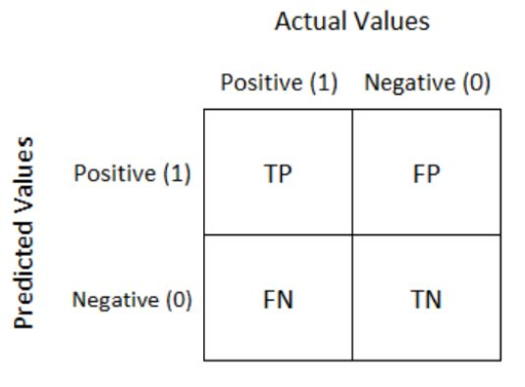
Fig 6.1 Actual Values

The following performance metrics are used to calculate the presentation of various algorithms.
- True positive (TP) – person has disease, and the prediction also has a positive
- True negative (TN) – person not having disease and the prediction also has a negative
- False positive (FP) – person not having disease but the prediction has a positive
- False negative (FN) – person having disease and the prediction also has a positive
- TP and TN can be used to calculate accuracy rate and the error rates can be computed using FP and FN values.
- True positive rate can be calculated as TP by a total number of persons have disease in reality.
- False positive rate can be calculated as FP by a total number of persons do not have disease in reality.
- Precision is TP/ total number of persons have prediction result is yes.
- Accuracy is the total number of correctly classified records

Accuracy- We have chosen accuracy matrix to measure the performance of all the models. The ratio of number of correct predictions to the total number of predictions Made.

Accuracy = Number of correct Prediction
Total numbers of predictions made.

RESULTS AND DISCUSSION

Machine learning classification algorithms developed for prediction of diabetes in earlier stage. We used 70% of data for tinning and 30% of data for testing. In this ratio of data splitting Here we found that Random Forest Classifier predicted with 99% of accuracy as highest accuracy for the dataset. Comparison of results of all the implemented classifiers are listed in below.

Machine Learning Algorithms | Result
Logistic Regression | 79.0
K-Nearest Neighbors | 80.5
SVM | 84.5
Naïve Bayes | 76.83
Decision Tree | 96.0
Random Forest | 98.0
AdaBoost Classifier | 81.16
Fig 7.1 Results

Creating a User Interface for Accessibility:

The last part of the project is the creation of a user interface for the model. This user interface is used to enter unseen data for the model to read and then make a prediction. The user interface is created using “Flask” Web app, Hyper Text Markup Language, and Cascading Style Sheets.

Results and Analysis

The project predicts the onset of diabetes in a person based on the relevant medical details collected. When the person enters all the relevant medical data required in the online Web portal, this data is then passed on to the trained model for it to make predictions whether the person is diabetic or non-diabetic the model then makes the prediction with an accuracy of98%, which is fairly good and reliable. Following figure shows the basic UI form which requires the user to enter the specific medical data fields. These parameters help determine if the person is prone to develop diabetes Our research has the added benefit of an associated Web app, which makes the model more user friendly and easily understandable for a novice.

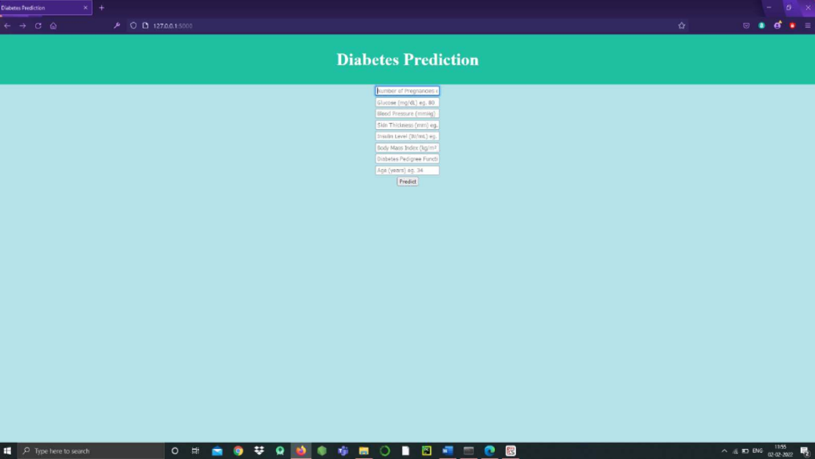Fig 8.1 : Basic Design of UI

On submission of this form, data the model gives the result in the form of Text; as shown in
following figures;
On submission of this form, data the model gives the result in the form of Text; as shown in following figures;
Fig 8.2 : Prediction for non-diabetic person

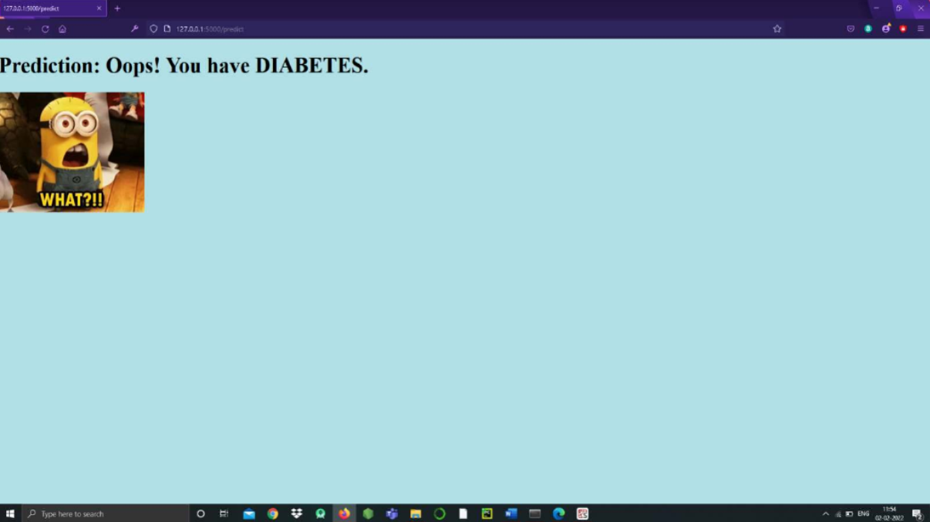Fig 8.3 :- Prediction for diabetic person

Conclusion

The objective of the project was to develop a model which could identify patients with
diabetes who are at high risk of hospital admission. Prediction of risk of hospital admission
is a fairly complex task. Many factors influence this process and the outcome. There is
presently a serious need for methods that can increase healthcare institution’s understanding
of what is important in predicting the hospital admission risk. This project is a small
contribution to the present existing methods of diabetes detection by proposing a system that
can be used as an assistive tool in identifying the patients at greater risk of being diabetic.
This project achieves this by analyzing many key factors like the patient’s blood glucose
level, body mass index, etc., using various machine learning models and through
retrospective analysis of patients’ medical records. The project predicts the onset of diabetes
in a person based on the relevant medical details that are collected using aWeb
application.When the user enters all the relevant medical data required in the online Web
application, this data is then passed on to the trained model for it to make predictions
whether the person is diabetic or nondiabetic. The model is developed using artificial neural
network consists of total of six dense layers. Each of these layers is responsible for the
efficient working of the model. The model makes the prediction with an accuracy of 98%,
which is fairly good and reliable.
The objective of the project was to develop a model which could identify patients with
diabetes who are at high risk of hospital admission. Prediction of risk of hospital admission
is a fairly complex task. Many factors influence this process and the outcome. There is
presently a serious need for methods that can increase healthcare institution’s understanding
of what is important in predicting the hospital admission risk. This project is a small
contribution to the present existing methods of diabetes detection by proposing a system that
can be used as an assistive tool in identifying the patients at greater risk of being diabetic.
This project achieves this by analyzing many key factors like the patient’s blood glucose
level, body mass index, etc., using various machine learning models and through
retrospective analysis of patients’ medical records. The project predicts the onset of diabetes
in a person based on the relevant medical details that are collected using aWeb
application.When the user enters all the relevant medical data required in the online Web
application, this data is then passed on to the trained model for it to make predictions
whether the person is diabetic or nondiabetic. The model is developed using artificial neural
network consists of total of six dense layers. Each of these layers is responsible for the
efficient working of the model. The model makes the prediction with an accuracy of 98%,
which is fairly good and reliable.
The objective of the project was to develop a model which could identify patients with
diabetes who are at high risk of hospital admission. Prediction of risk of hospital admission
is a fairly complex task. Many factors influence this process and the outcome. There is
presently a serious need for methods that can increase healthcare institution’s understanding
of what is important in predicting the hospital admission risk. This project is a small
contribution to the present existing methods of diabetes detection by proposing a system that
can be used as an assistive tool in identifying the patients at greater risk of being diabetic.
This project achieves this by analyzing many key factors like the patient’s blood glucose
level, body mass index, etc., using various machine learning models and through
retrospective analysis of patients’ medical records. The project predicts the onset of diabetes
in a person based on the relevant medical details that are collected using aWeb
application.When the user enters all the relevant medical data required in the online Web
application, this data is then passed on to the trained model for it to make predictions
whether the person is diabetic or nondiabetic. The model is developed using artificial neural
network consists of total of six dense layers. Each of these layers is responsible for the
efficient working of the model. The model makes the prediction with an accuracy of 98%,
which is fairly good and reliable.
The objective of the project was to develop a model which could identify patients with
diabetes who are at high risk of hospital admission. Prediction of risk of hospital admission
is a fairly complex task. Many factors influence this process and the outcome. There is
presently a serious need for methods that can increase healthcare institution’s understanding
of what is important in predicting the hospital admission risk. This project is a small
contribution to the present existing methods of diabetes detection by proposing a system that
can be used as an assistive tool in identifying the patients at greater risk of being diabetic.
This project achieves this by analyzing many key factors like the patient’s blood glucose
level, body mass index, etc., using various machine learning models and through
retrospective analysis of patients’ medical records. The project predicts the onset of diabetes
in a person based on the relevant medical details that are collected using aWeb
application.When the user enters all the relevant medical data required in the online Web
application, this data is then passed on to the trained model for it to make predictions
whether the person is diabetic or nondiabetic. The model is developed using artificial neural
network consists of total of six dense layers. Each of these layers is responsible for the
efficient working of the model. The model makes the prediction with an accuracy of 98%,
which is fairly good and reliable.
The objective of the project was to develop a model which could identify patients with
diabetes who are at high risk of hospital admission. Prediction of risk of hospital admission
is a fairly complex task. Many factors influence this process and the outcome. There is
presently a serious need for methods that can increase healthcare institution’s understanding
of what is important in predicting the hospital admission risk. This project is a small
contribution to the present existing methods of diabetes detection by proposing a system that
can be used as an assistive tool in identifying the patients at greater risk of being diabetic.
This project achieves this by analyzing many key factors like the patient’s blood glucose
level, body mass index, etc., using various machine learning models and through
retrospective analysis of patients’ medical records. The project predicts the onset of diabetes
in a person based on the relevant medical details that are collected using aWeb
application.When the user enters all the relevant medical data required in the online Web
application, this data is then passed on to the trained model for it to make predictions
whether the person is diabetic or nondiabetic. The model is developed using artificial neural
network consists of total of six dense layers. Each of these layers is responsible for the
efficient working of the model. The model makes the prediction with an accuracy of 98%,
which is fairly good and reliable.
The objective of the project was to develop a model which could identify patients with
diabetes who are at high risk of hospital admission. Prediction of risk of hospital admission
is a fairly complex task. Many factors influence this process and the outcome. There is
presently a serious need for methods that can increase healthcare institution’s understanding
of what is important in predicting the hospital admission risk. This project is a small
contribution to the present existing methods of diabetes detection by proposing a system that
can be used as an assistive tool in identifying the patients at greater risk of being diabetic.
This project achieves this by analyzing many key factors like the patient’s blood glucose
level, body mass index, etc., using various machine learning models and through
retrospective analysis of patients’ medical records. The project predicts the onset of diabetes
in a person based on the relevant medical details that are collected using aWeb
application.When the user enters all the relevant medical data required in the online Web
application, this data is then passed on to the trained model for it to make predictions
whether the person is diabetic or nondiabetic. The model is developed using artificial neural
network consists of total of six dense layers. Each of these layers is responsible for the
efficient working of the model. The model makes the prediction with an accuracy of 98%,
which is fairly good and reliable.
The objective of the project was to develop a model which could identify patients with
diabetes who are at high risk of hospital admission. Prediction of risk of hospital admission
is a fairly complex task. Many factors influence this process and the outcome. There is
presently a serious need for methods that can increase healthcare institution’s understanding
of what is important in predicting the hospital admission risk. This project is a small
contribution to the present existing methods of diabetes detection by proposing a system that
can be used as an assistive tool in identifying the patients at greater risk of being diabetic.
This project achieves this by analyzing many key factors like the patient’s blood glucose
level, body mass index, etc., using various machine learning models and through
retrospective analysis of patients’ medical records. The project predicts the onset of diabetes
in a person based on the relevant medical details that are collected using aWeb
application.When the user enters all the relevant medical data required in the online Web
application, this data is then passed on to the trained model for it to make predictions
whether the person is diabetic or nondiabetic. The model is developed using artificial neural
network consists of total of six dense layers. Each of these layers is responsible for the
efficient working of the model. The model makes the prediction with an accuracy of 98%,
which is fairly good and reliable.
The objective of the project was to develop a model which could identify patients with
diabetes who are at high risk of hospital admission. Prediction of risk of hospital admission
is a fairly complex task. Many factors influence this process and the outcome. There is
presently a serious need for methods that can increase healthcare institution’s understanding
of what is important in predicting the hospital admission risk. This project is a small
contribution to the present existing methods of diabetes detection by proposing a system that
can be used as an assistive tool in identifying the patients at greater risk of being diabetic.
This project achieves this by analyzing many key factors like the patient’s blood glucose
level, body mass index, etc., using various machine learning models and through
retrospective analysis of patients’ medical records. The project predicts the onset of diabetes
in a person based on the relevant medical details that are collected using aWeb
application.When the user enters all the relevant medical data required in the online Web
application, this data is then passed on to the trained model for it to make predictions
whether the person is diabetic or nondiabetic. The model is developed using artificial neural
network consists of total of six dense layers. Each of these layers is responsible for the
efficient working of the model. The model makes the prediction with an accuracy of 98%,
which is fairly good and reliable.
The objective of the project was to develop a model which could identify patients with
diabetes who are at high risk of hospital admission. Prediction of risk of hospital admission
is a fairly complex task. Many factors influence this process and the outcome. There is
presently a serious need for methods that can increase healthcare institution’s understanding
of what is important in predicting the hospital admission risk. This project is a small
contribution to the present existing methods of diabetes detection by proposing a system that
can be used as an assistive tool in identifying the patients at greater risk of being diabetic.
This project achieves this by analyzing many key factors like the patient’s blood glucose
level, body mass index, etc., using various machine learning models and through
retrospective analysis of patients’ medical records. The project predicts the onset of diabetes
in a person based on the relevant medical details that are collected using aWeb
application.When the user enters all the relevant medical data required in the online Web
application, this data is then passed on to the trained model for it to make predictions
whether the person is diabetic or nondiabetic. The model is developed using artificial neural
network consists of total of six dense layers. Each of these layers is responsible for the
efficient working of the model. The model makes the prediction with an accuracy of 98%,
which is fairly good and reliable.
The objective of the project was to develop a model which could identify patients with diabetes who are at high risk of hospital admission. Prediction of risk of hospital admission is a fairly complex task. Many factors influence this process and the outcome. There is presently a serious need for methods that can increase healthcare institution’s understanding of what is important in predicting the hospital admission risk. This project is a small contribution to the present existing methods of diabetes detection by proposing a system that can be used as an assistive tool in identifying the patients at greater risk of being diabetic. This project achieves this by analyzing many key factors like the patient’s blood glucose level , body mass index , etc., using various machine learning models and through retrospective analysis of patients’ medical records. The project predicts the onset of diabetes in a person based on the relevant medical details that are collected using a Web application. When the user enters all the relevant medical data required in the online Web application, this data is then passed on to the trained model for it to make predictions whether the person is diabetic or nondiabetic. The model is developed using artificial neural network consists of total of six dense layers. Each of these layers is responsible for the efficient working of the model. The model makes the prediction with an accuracy of 98%, which is fairly good and reliable.

References

- Diabetes Prediction – dataset informatics-edu – Data.world
Real patient data to manipulate and to predict diabetes (yes or no) using demographic and lab variables.
https://data.world/informatics-edu/diabetes-prediction

- Datasets/diabetes.csv at master . plotly/datasets – GitHub https://github.com/plotly/datasets/blob/master/diabetes.csv

- Diabetes – Dataset – DataHub – Frictionless Data
The resources for this dataset can be found at https://www.openml.org/d/37 Author: Vincent Sigillito Source: Obtained from UCI Please cite: UCI citation policy Title: Pima Indians Diabetes Database Sources.
https://datahub.io/machine-learning/diabetes
- Diabetes.csv – Kaggle
https://www.kaggle.com/saurabh00007/diabetescsv

